# CIS7 Project Part 1 Team Task Assignment:

**Deadline: 12/3 – 12/7 (Week Before Finals)**

**Worth 15% of your grade!**

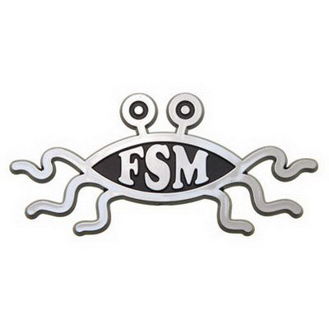

Team Name: FSM (Flying Spaghetti Monster)

Team Members and Assigned Tasks:

Devan Vegiga –

Discord: @delishuscake#3046

Email: devanvegiga@outlook.com

Phone: 951-907-9017

Randy Son –

Discord: @Randy#6779

Email: rson@csumb.edu

Phone: 909-362-0853

**Projected Task Completion Timeline**:

11/15 – Pseudocode

Contact Exchange

11/16 – Around 15:30 @ Rock Ridge Park

Pseudocode, program outlook

11/23 – Class structure barebones + encrypt/decrypt functions

11/30 – Testing and debugging

12/07 – Ready for release